**Project Design Phase-II**

**Technology Stack (Architecture & Stack)**

|  |  |
| --- | --- |
| Date | 27 JUNE 2025 |
| Team ID | LTVIP2025TMID20276 |
| Project Name | Citizen AI – Intelligent Citizen Engagement Platform |
| Maximum Marks | 4 Marks |

**Technical Architecture:**

The Deliverable shall include the architectural diagram as below and the information as per the table1 & table

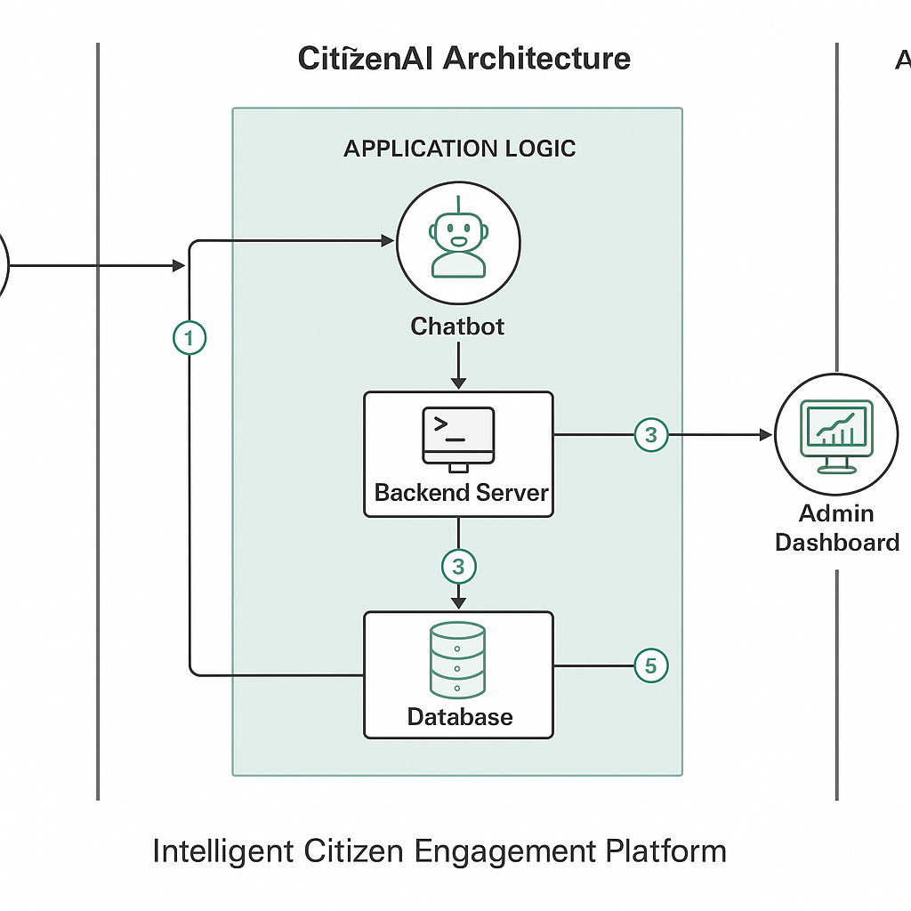

**Table 1: Components & Technologies**

|  |  |  |  |
| --- | --- | --- | --- |
| **S.No** | **Component** | **Description** | **Technology** |
| 1 | User Interface | Web UI + Chatbot for citizen interaction | HTML, CSS, JavaScript, Bootstrap |
| 2 | Application Logic - 1 | AI-based text processing and query handling | Python (Flask), Hugging Face GPT-2 |
| 3 | Application Logic - 2 | Sentiment Analysis module for feedback | Python TextBlob / NLTK |
| 4 | Application Logic - 3 | Dashboard logic for real-time visualization | Chart.js / Plotly + Flask Backend |
| 5 | Database | Store concerns, feedback, user data | SQLite (Local) / PostgreSQL (Cloud Ready) |
| 6 | Cloud Database (optional) | Database hosted on the cloud (for scale) | Azure PostgreSQL / Firebase Firestore |
| 7 | File Storage (optional) | Local file uploads or image storage | OS Filesystem / Firebase Storage |
| 8 | External API - 1 (Optional) | Geo-tagging civic complaints | Google Maps API |
| 9 | Machine Learning Model | Natural language responses | Hugging Face Transformers (GPT-2) |
| 10 | Infrastructure | Deployment & Hosting | Localhost, Azure App Services, PythonAnywhere |

**⚙️ Table 2: Application Characteristics**

|  |  |  |  |
| --- | --- | --- | --- |
| **S.No** | **Characteristics** | **Description** | **Technology** |
| 1 | Open-Source Frameworks | Rapid development and deployment | Flask, Bootstrap, Chart.js |
| 2 | Security Implementations | Protect admin access and inputs | Flask-Login, SHA-256 Encryption |
| 3 | Scalable Architecture | Easily expandable modules and layers | 3-Tier Architecture, RESTful APIs |
| 4 | Availability | Accessible 24/7 with local fallback | Azure Hosting + Auto-Restart Scripts |
| 5 | Performance | Optimized for low-latency response & visualization | Caching, Asynchronous Requests, JS Minify |